# **The Hospital**

**Base Facts**

**Patient:**

* Patient has an ID
* Patient has a Full Name
* Patient has an Address
* Patient has Date of Birth (DOB)
* Patient has an SSN
* Patient has an Insurance Membership ID
* Patient has deductible progress
* Patient has a status

**Procedure:**

* Procedure has an ID
* Procedure has a description
* Procedure has a code
* Procedure has a fee
* Procedure has a Department ID

**Procedure Supply Requirements**

* Procedure Supply Requirement has an ID
* Procedure Supply Requirement has a supplyCode
* Procedure Supply Requirement has a Procedure Code
* Procedure Supply Requirement has an item
* Procedure Supply Requirement has a description
* Procedure Supply Requirement has a quantity
* Procedure Supply Requirement has a quantityUnit
* Procedure Supply Requirement has a unit price

**Procedure Role Requirements**

* Procedure Role Requirement has an ID
* Procedure Role Requirement has a roleCode
* Procedure Role Requirement has a procedure code
* Procedure Role Requirement has a role
* Procedure Role Requirement has a description
* Procedure Role Requirement has a quantity
* Procedure Role Requirement is optional or not optional
* Procedure Role Requirement has a cost

**Appointment:**

* Appointment has an ID
* Appointment has a date
* Appointment has a start time
* Appointment has an end time
* Appointment has a Patient ID
* Appointment has a Provider ID
* Appointment has a Procedure Code
* Appointment has a room ID
* Appointment has a fee

**Insurance Agency:**

* Insurance Agency has ID
* Insurance Agency has name

**Insurance Plan:**

* Insurance Plan has an ID
* Insurance Plan has a deductible
* Insurance Plan has a title
* Insurance Plan has a description
* Insurance Plan has a post-deductible split
* Insurance Plan has an Insurance Agency

**Transaction**

* Transaction has an ID
* Transaction has a date
* Transaction has a payment source ID
* Transaction has an Appointment ID
* Transaction has a Patient ID
* Transaction has a total
* Transaction has a remaining balance
* Transaction has Payment Plan ID
* Transaction has a status
* A Transaction is either in-network or out-network
* A Transaction payment source is either a Patient or an Insurance Plan

**Room**

* Room has an ID
* Room has a name
* Room has a status
* Room has a department

**Staff**

* Staff has an ID
* Staff has a role
* Staff has a Name
* Staff has a department

**Role**

* Role has an ID
* Role has a title
* Role is either a provider or not a provider

**Department**

* Department has ID
* Department has name

**Claim**

* Claim has ID
* Claim has date
* Claim has insurance membership ID
* Claim has patient ID
* Claim has appointment ID
* Claim has Payment Plan ID
* Claim has paid deductible value
* Claim has Patient copay value
* Claim has insurance pay value
* Claim has a status
* Claim has adjustments

**Payment Plan**

* Payment Plan has an ID
* Payment Plan has a Title
* Payment Plan has Payment Period
* Payment Plan has monthly minimum
* Payment Plan has paid principle
* Payment Plan has monthly interest

**Aggregated Adjustments**

* Aggregated Adjustment has an ID
* Aggregated Adjustment has an Insurance Agency
* Aggregated Adjustment has an Insurance Plan
* Aggregated Adjustment has a total

**Constraints**

1. A Patient must provide a legal full name
2. A Patient must provide a home address
3. A Patient must provide a date of birth
4. A Patient may provide a SSN
5. A Patient must have a unique ID
6. A Patient may have a unique insurance membership ID
7. A Patient may have progress towards their annual deductible
8. A Patient must have a status
9. A Procedure must have an ID
10. A Procedure must have a Code
11. A Procedure must have a description
12. A Procedure must have a fee
13. A Procedure must have a department
15. A Procedure Role Requirement must have an ID
16. A Procedure Role Requirement must have a roleCode
17. A Procedure Role Requirement must have a procedure code
18. A Procedure Role Requirement must have a required role
19. A Procedure Role Requirement must have a description
20. A Procedure Role Requirement must have a quantity
21. A Procedure Role Requirement must have a Cost
22. A Procedure Role Requirement must specify if the requirement is optional or not
23. A Procedure Supply Requirement must have an ID
24. A Procedure Supply Requirement must have a supply code
25. A Procedure Supply Requirement must have a procedure code
26. A Procedure Supply Requirement must have an item
27. A Procedure Supply Requirement must have a description
28. A Procedure Supply Requirement must have a unit price
29. A Procedure Supply Requirement must have a quantity
30. A Procedure Supply Requirement must have a quantity unit
31. An Appointment must have an ID
32. An Appointment must have a Room ID
33. An Appointment must have a scheduled datetime
34. An Appointment must have a start time
35. An Appointment must have an end time
36. An Appointment must have a Patient ID
37. An Appointment must have a Provider ID
38. An Appointment must have a Procedure Code
39. An Appointment must have a Fee
40. An Insurance Plan must have an ID
41. An Insurance Plan must have a title
42. An Insurance Plan must have a description
43. An Insurance Plan must have a deductible
44. An Insurance Plan must have an insurance agency
45. An Insurance Plan must have a post-deductible split
46. A Transaction must have an ID
47. A Transaction must have a date
48. A Transaction must have an Appointment ID
49. A Transaction must have a Patient ID
50. A Transaction may have the patient’s insurance plan ID
51. A Transaction requires a total
52. A Transaction requires a remaining balance
53. A Transaction requires a payment plan ID
54. A Transaction requires a status
55. A Transaction must be in-network or out-network
56. A Transaction must be paid either by a Patient or by an Insurance Plan
57. A Room requires an ID
58. A Room requires a name
59. A Room requires a status
60. A Room requires a department
61. Staff needs an ID
62. Staff requires a role
63. Staff requires a name
64. Staff requires a department
65. Role requires an ID
66. Roles requires a Title
67. Roles must either be a Provider or Not Provider
68. A Department requires an ID
69. A Department requires a name
70. A Claim must have an ID
71. A Claim must have a date
72. A Claim must have a patient ID
73. A Claim must have an insurance membership ID
74. A Claim must have an appointment ID
75. A Claim must have a payment plan ID
76. A Claim must have adjustments
77. A Claim must have a patient copay value
78. A Claim must have a paid deductible value
79. A Claim must have an insurance pay value
80. A Claim must have a status
81. A Payment Plan requires an ID
82. A Payment Plan requires a title
83. A Payment Plan requires a payment period measured in days
84. A Payment Plan requires a monthly minimum pay
85. A Payment Plan requires a paid principle
86. A Payment Plan needs monthly interest
87. An Insurance Agency requires an ID
88. An Insurance Agency requires a name
89. An Aggregated Adjustment requires an ID
90. An Aggregated Adjustment requires an Insurance Agency
91. An Aggregated Adjustment requires an Insurance Plan
92. An Aggregated Adjustment requires a total.

**Derivation Rules**

1. Total patients seen by Insurance/Plan = Count each Member ID associated with specified Insurance Plan

SELECT PlanID, COUNT(*) AS TotalCount

FROM PlanMembershipJoin

GROUP BY PlanID

1. Total money received by Insurance/Plan = Add up all the Totals from each Transaction associated with specified Insurance Plan

SELECT PatientInsurancePlan, SUM(Total) AS 'Recieved Insurance Pay'

FROM Transactions

WHERE PatientInsurancePlan IS NOT NULL

GROUP BY PatientInsurancePlan

1. Patients with Incomplete Payment Plans = For each Transaction with a remaining balance, return the Patient ID

SELECT Patients.PatientID, Patients.FullName, SUM(Transactions.RemainingBalance) AS 'Remaining Balance' FROM Transactions

LEFT JOIN PaymentPlans ON PaymentPlans.PlanID = Transactions.PaymentPlanID

LEFT JOIN Appointment ON Appointment.AppointmentID = Transactions.AppointmentID

LEFT JOIN Patients ON Patients.PatientID = Transactions.PatientID

WHERE PaymentPlans.PaidPrinciple <= Appointment.Fee

GROUP BY Patients.PatientID, Patients.FullName

1. Count of procedures by procedure code = Count each Appointment by specified Procedure Code

SELECT ProcedureCode, COUNT(*) AS 'Total Appointments' FROM Appointment

GROUP BY ProcedureCode

1. Count of procedures by provider/procedure code = Count each Appointment by specified Provider ID AND specified Procedure Code

SELECT fullName, ProcedureCode, COUNT(*) AS 'Total Appointments' FROM Appointment

Left JOIN Staff ON Staff.StaffID = Appointment.ProviderID

GROUP BY fullName, ProcedureCode

1. Total $ amount of denied claims = For each Claim with a “Denied” Status, aggregate the Insurance Pay Value

SELECT SUM(InsurancePay) AS TotalDeniedInsurancePay

FROM Claims

WHERE ClaimStatus = 'S005';

1. Patients with deductibles met = Return all Patients with Deductible Progress == 0

SELECT * FROM Patients

LEFT JOIN PlanMembershipJoin ON PlanMembershipJoin.MembershipID = Patients.InsuranceMembershipID

LEFT JOIN InsurancePlan ON InsurancePlan.PlanID = PlanMembershipJoin.PlanID

WHERE Patients.DeductibleProgress >= InsurancePlan.Deductible

**CSDP Quality Check Transactions**

* 1. Add Insurance Agency

ID: IA_0232_9233

Transaction FAILED BECAUSE of C89 (Missing Name)

* 1. Add Insurance Agency

ID: IA_0232_9233

Name: L&G Mega Health

* 1. Add Insurance Agency

ID: IA_0232_9253

Name: Johnson Brothers Health

* 1. Delete Insurance Agency

ID: IA_0232_9290

Transaction FAILED BECAUSE of C88 (Wrong ID)

* 1. Delete Insurance Agency

ID: IA_0232_9253

* 1. Add Insurance Plan

ID: IP_39203_0124

Title: Golden Plan

Description: This plan covers 100% of the medical bills after reaching the deductible.

Insurance Agency: L&G Mega Health

Post Deductible Split: 0.00

Transaction FAILED BECAUSE of C44 (Missing Deductible)

1. Add Insurance Plan

ID: IP_3920_0124

Title: Golden Plan

Description: This plan covers 100% of the medical bills after reaching the deductible.

Deductible: $3000

Insurance Agency: L&G Mega Health

Post Deductible Split: 0.00

1. Add Insurance Plan

ID: IP_3920_2401

Title: Silver Plan

Description: This plan covers 80% of the medical bills after reaching the deductible.

Deductible: $2000

Insurance Agency: L&G Mega Health

Post Deductible Split: 0.20

1. Delete Insurance Plan

ID: IP_39203_2402

Transaction FAILED BECAUSE of C41 (Wrong ID)

1. Delete Insurance Plan

ID: IP_39203_2401

1. Add: Patient

ID: PA_0283_9468

Name: “Mark Johnson”

Address: 241 S Long St. Salt Lake City, UT 84103

DOB: 07/20/1984

Insurance Membership ID: IM_3920_0124

Annual Deductible: $475

Status: In patient

Transaction FAILED Because of C4 (Missing SSN)

1. Add Patient

ID: PA_0283_9468

Name: “Mark Johnson”

Address: 241 S Long St. Salt Lake City, UT 84103

DOB: 07/20/1984

SSN: 007 02 0083

Insurance Membership ID: IM_3920_0124

Annual Deductible: $4756.

Status: In patient

1. Add Patient

ID: PA_0283_9470

Name: “John Johnson”

Address: 241 S Short St. Salt Lake City, UT 84143

DOB: 06/10/1994

SSN: 057 06 0123

Insurance Membership ID: IM _3920_0124

Status: In patient

Annual Deductible: $

1. Delete Patient

ID: PA_0283_9475

Transaction FAILED BECAUSE of C5 (Wrong ID)

1. Delete Patient

ID: PA_0283_9470

1. Add Department

ID:DP_9324

Transaction FAILED BECAUSE of C70 (Missing Name)

1. Add Department

ID:DP_9324

Name: Emergencies

1. Add Department

ID:DP_9330

Name: Cardiology

1. Delete Department

ID: DP_9350

Transaction FAILED BECAUSE of C69 (Wrong ID)

1. Delete Department

ID:DP_9330

1. Add Procedure

ID: PC_02941

Description: fix broken leg

Code: PC_3252_8495_2349

Department: DP_9324

Transaction FAILED BECAUSE of C12 (No Fee)

1. Add Procedure

ID: PC_02941

Description: fix broken leg

Code: PC_3252_8495_2349

Fee: $2400

Department: DP_9324

1. Add Procedure

ID: PC_03441

Description: fix broken arm

Code: PC_3252_8255_2349

Fee: $1800

Department: DP_9324

1. Delete Procedure

ID: PC_03442

Transaction FAILED BECAUSE of C10 (Wrong ID)

1. Delete Procedure

ID: PC_03441

1. Add Role

ID:RL_0325

IsProvider: True

Transaction FAILED BECAUSE of C67 (Missing Title)

1. Add Role

ID:RL_0325

Title: Surgeon

IsProvider: True

1. Add Role

ID:RL_0343

Title: Receptionist

IsProvider: False

1. Delete Role

ID:RL_0345

Transaction FAILED BECAUSE of C66 (Wrong ID)

1. Delete Role

ID:RL_0343

1. Add Procedure Role Requirement

ID: 393202302

Role Code: RC_302_292_392

Procedure Code: PC_3252_8495_2349

Description: For the procedure only one Doctor is required

Quantity: 1

Cost: $1000

Requirement: Not optional

Transaction FAILED BECAUSE of C19 (Missing Role)

1. Add Procedure Role Requirement

ID: PR_3932_0230

Role Code: RC_302_292_392

Procedure Code: PC_3252_8495_2349

Role: RL_0325

Description: For the procedure only one Doctor is required

Quantity: 1

Cost: $1000

Requirement: Not optional

1. Add Procedure Role Requirement

ID: PR_3932_0250

Role Code: RC_112_356_392

Procedure Code: PC_3342_8415_5349

Role: RL_0325

Description: For the procedure two Doctors are required

Quantity: 2

Cost: $2500

Requirement: Not optional

1. Delete Procedure Role Requirement

ID: 2 PR_3932_0270

Transaction FAILED BECAUSE of C16 (Wrong ID)

1. Delete Procedure Role Requirement

ID: PR_3932_0250

1. Add Procedure Supply Requirement

ID:PS_ 3020_0933

Supply Code: SR_381_923_293

Procedure Code: PC_3252_8495_2349

Item: Ibuprofen

Description: Nonsteroidal anti-inflammatory drug

Price: $ 3.00

Quantity: 2

Transaction FAILED BECAUSE of C31 (Missing quantity unit)

1. Add Procedure Supply Requirement

ID: PS_ 3020_0933

Supply Code: SR_381_923_293

Procedure Code: PC_3252_8495_2349

Item: Ibuprofen

Description: Nonsteroidal anti-inflammatory drug

Price: $ 3.00

Quantity: 2

Quantity Unit: mg

1. Add Procedure Supply Requirement

ID: PS_ 3020_0963

Supply Code: SR_381_925_293

Procedure Code: PC_3252_8495_2349

Item: Simponi

Description: Monoclonal antibody

Price: $ 7.00

Quantity: 1

Quantity Unit: mg

1. Delete Procedure Supply Requirement

ID: PS_ 3020_777

Transaction FAILED BECAUSE of C24 (Wrong ID)

1. Delete Procedure Supply Requirement

ID: PS_ 3020_0963

1. Add Room

ID: 4378

Name: Patient 4 Room

Department: DP_9324

Transaction FAILED BECAUSE of C60 (Room Status)

1. Add Room

ID: 4378

Name: Patient 4 Room

Status: Unavailable

Department: DP_9324

1. Add Room

ID: 4380

Name: Patient 3 Room

Status: Available

Department: DP_9324

1. Delete Room

ID:4398

Transaction FAILED BECAUSE of C58 (Wrong ID)

1. Delete Room

ID:4380

1. Add Staff

ID: ST_0325_0342

Name: Shaun Murphy

Department: DP_9324

Transaction FAILED BECAUSE of C63 (Missing Role)

1. Add Staff

ID: ST_0325_0342

Role: RL_0325

Name: Gregory House

Department: DP_9324

1. Add Staff

ID: ST_0325_0343

Role: RL_0325

Name: Shaun Murphy

Department: DP_9324

1. Delete Staff

ID: ST_0325_0350

Transaction FAILED BECAUSE of C62 (Wrong ID)

1. Delete Staff

ID: ST_0325_0343

1. Add Appointment

ID: AP_5032_0949

Room ID: 4378

Date: 07/23/2023

Start Time: 9:00 AM

End Time: 11:00 AM

Provider ID: ST_0325_0342

Procedure Code: PC_3252_8495_2349

Fee: $3000

Transaction FAILED BECAUSE of C37 (Missing Patient ID)

1. Add Appointment

ID: AP_5032_0949

Room ID: 4378

Date: 07/23/2023

Start Time: 9:00 AM

End Time: 11:00 AM

Patient ID: PA_0283_9470

Provider ID: ST_0325_0342

Procedure Code: PC_3252_8495_2349

Fee: $3000

1. Add Appointment

ID: AP_5032_0950

Room ID: 4376

Date: 07/21/2023

Start Time: 10:00 AM

End Time: 12:00 AM

Patient ID: PA_0283_9470

Provider ID: ST_0325_0342

Procedure Code: PC_3252_8495_2349

Fee: $2500

1. Delete Appointment

ID: AP_5032_0954

Transaction FAILED BECAUSE of C32 (Wrong ID)

1. Delete Appointment

ID: AP_5032_0949

1. Add Payment Plan

ID: PP_02334_4246

Title: Quick Payback

Payment Period: 180

Paid Principle: $50

Monthly Interest: 0.04

Transaction FAILED BECAUSE of C85 (Missing Monthly Minimum)

1. Add Payment Plan

ID: PP_02334_4246

Title: Quick Payback

Payment Period: 180

Monthly Minimum: $100

Paid Principle: $50

Monthly Interest: 0.04

1. Add Payment Plan

ID: PP_02334_4232

Title: Slow Payback

Payment Period: 1080

Monthly Minimum: $30

Paid Principle: $20

Monthly Interest: 0.10

1. Delete Payment Plan

ID: PP_02334_4278

Transaction FAILED BECAUSE of C82 (Wrong ID)

1. Delete Payment Plan

ID: PP_02334_4232

1. Add Transaction

ID:TR_0326_0325

Date: 07/23/2023

Appointment ID: AP_5032_0949

Patient ID: P02839

Payment Source ID: IM_39203_0124

Total: $3000

Payment Plan ID: PP_9432_0424

Status: Pending

Network Type: In-network

Transaction FAILED BECAUSE of C53 (Remaining Balance)

1. Add Transaction

ID: TR_0326_0325

Date: 07/23/2023

Appointment ID: AP_5032_0949

Patient ID: PA_0283_9468

Payment Source ID: IM_39203_0124

Total: $3000

Remaining Balance: $3000

Payment Plan ID: PP_9432_0424

Status: Pending

Network Type: In-network

Paid by: Insurance Plan

1. Add Transaction

ID:TR_0326_0315

Date: 07/23/2023

Appointment ID: AP_5032_0949

Patient ID: PA_0283_9468

Payment Source ID: IM_39203_0124

Total: $2500

Remaining Balance: $1000

Payment Plan ID: PP_9432_0424

Status: Pending

Network Type: out-network

Paid by: Insurance Plan

1. Delete Transaction

ID: TR_0326_0351

Transaction FAILED BECAUSE of C47 (Wrong ID)

1. Delete Transaction

ID: TR_0326_0315

1. Add Claim

ID:CL_0235

Date: 09/23/2023

Patient ID: PA_0283_9468

Insurance Membership ID: IM_39203_0124

Appointment ID: AP_5032_0949

Payment Plan ID: PP_02334_4246

Patient Copay Value: $0

Paid Deductible Value: $200

Insurance Pay Value: $0

Status: In Progress

Transaction FAILED BECAUSE of C77 (Adjustment Missing)

1. Add Claim

ID:CL_0235

Date: 07/23/2023

Patient ID: PA_0283_9468

Insurance Membership ID: IM_39203_0124

Appointment ID: AP_5032_0949

Payment Plan ID: PP_02334_4246

Adjustments: $0

Patient Copay Value: $0

Paid Deductible Value: $200

Insurance Pay Value: $0

Status: In Progress

1. Add Claim

ID:CL_0254

Date: 07/25/2023

Patient ID: PA_0283_9468

Insurance Membership ID: IM _39203_0124

Appointment ID: AP_5032_0949

Payment Plan ID: PP_02334_4246

Adjustments: $1250

Patient Copay Value: $250

Paid Deductible Value: $450

Insurance Pay Value: $3421

Status: Completed

1. Delete Claim

ID: CL_0256

Transaction FAILED BECAUSE of C71 (Wrong ID)

1. Delete Claim

ID:CL_0254

1. Add Aggregated Adjustment

ID:AA_0345_5394

Insurance Plan: IP_39203_0124

Total: $34.530

Transaction FAILED BECAUSE of C91 (Missing Insurance Agency)

1. Add Aggregated Adjustment

ID:AA_0345_5394

Insurance Agency: IA_0232_9233

Insurance Plan: IP_39203_0124

Total: $34.530

1. Add Aggregated Adjustment

ID:AA_0345_5396

Insurance Agency: IA_0232_9263

Insurance Plan: IP_39203_0108

Total: $27.210

1. Delete Aggregated Adjustment

ID:AA_0345_5334

Transaction FAILED BECAUSE of C90 (Wrong ID)

1. Delete Aggregated Adjustment

ID:AA_0345_5396

**Diagrams**

UML Class Diagram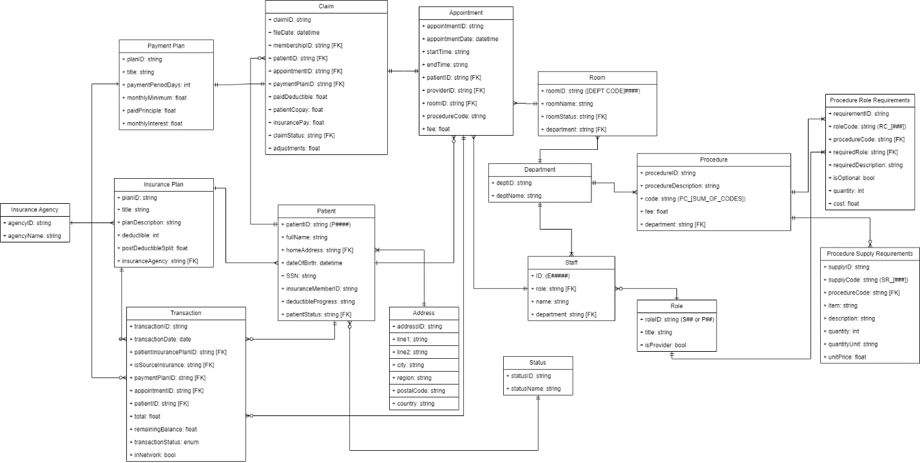Entity Relationship Diagram

Activity Diagram

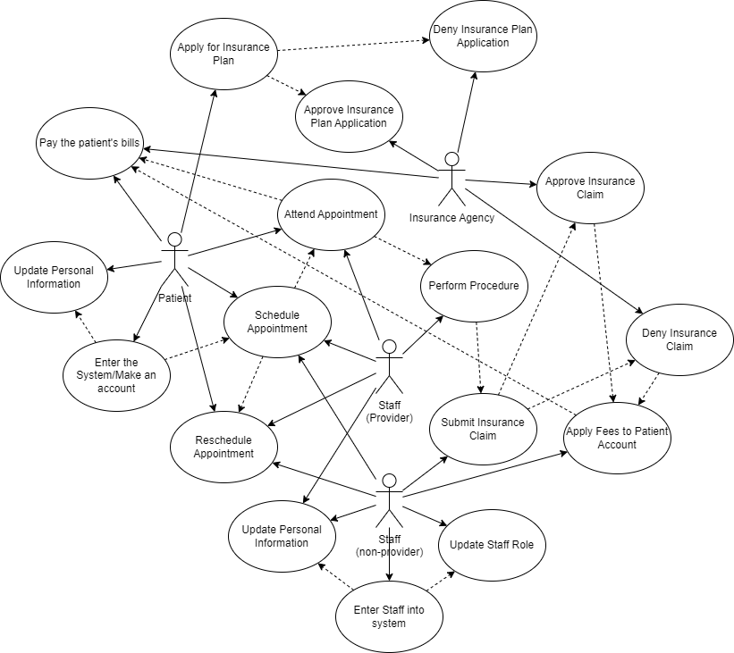

Swimlane Flowchart Diagram:

